**“Experiment 1.3”**

Student Name: **SUMIT KUMAR** UID: **20BCS8226**

Branch: **CSE** Section/Group: **808 A**

Semester: **5th** Date of Submission: **05-09-22**

Subject Name: **Machine Learning Lab** Subject Code: **CSP-317**

1. **Aim:**

 Implement Linear Regression on any data set.

1. **Software/Hardware Requirements:**

Windows 7 & above version

1. **Tools to be used:**

* Google Colab
* Python programming language

1. **Theory:**

**Linear Regression – Finding a straight line of best fit through the data .This works well when the true underlying function is linear.** A linear model makes a "hypothesis" about the true nature of the underlying function - that it is linear. We express this hypothesis in the univariate case as

*hθ*(*x*)=*ax*+*b*

Our simple example above was an example of "univariate regression" - i.e. just one variable (or "feature") - number of hours studied. Below we will have more than one feature ("multivariate regression") which is given by

*hθ*(**x**)=**a**⊤**X**

Here **a** is a vector of learned parameters, and **X** is the "design matrix" with all the data points. In this formulation the intercept term has been added to the design matrix as the first column (of all ones).

1. **Code & Output:**

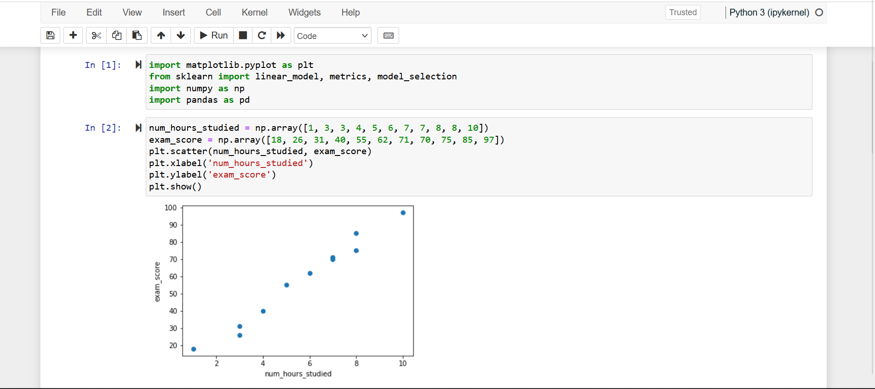

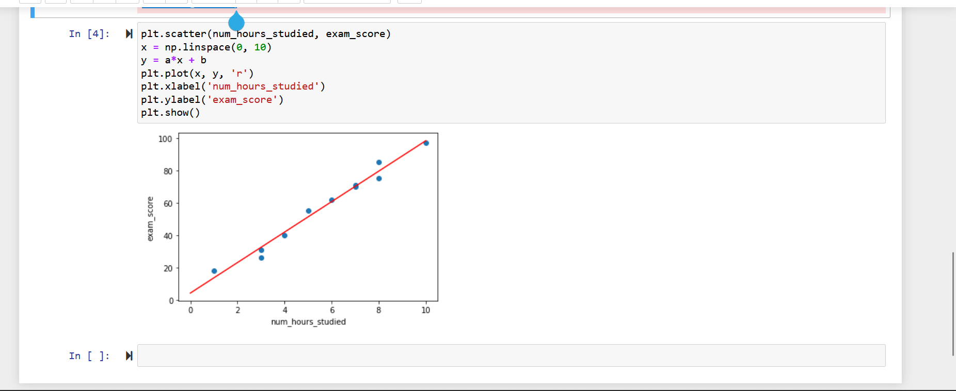

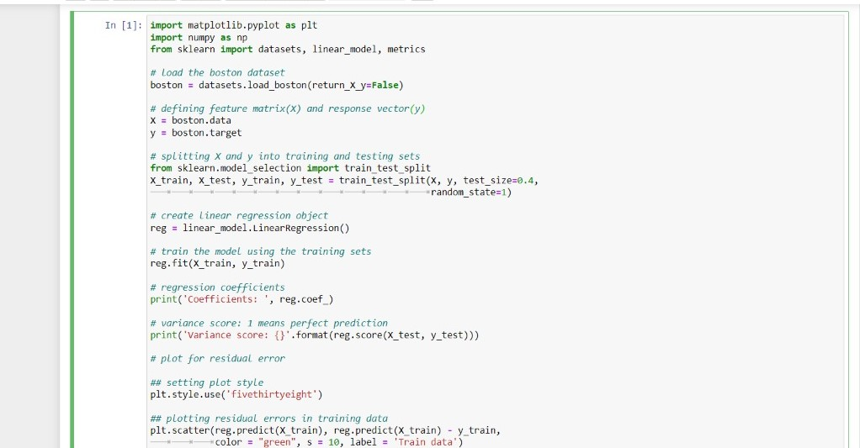

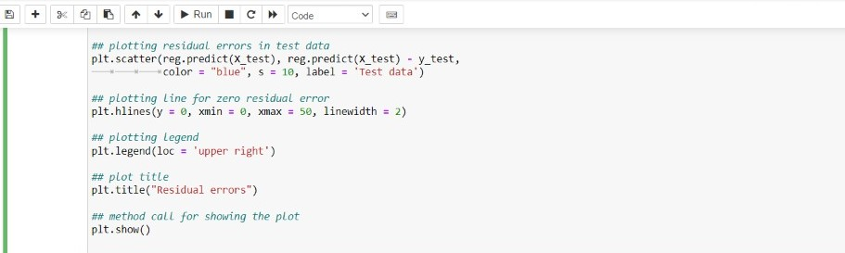

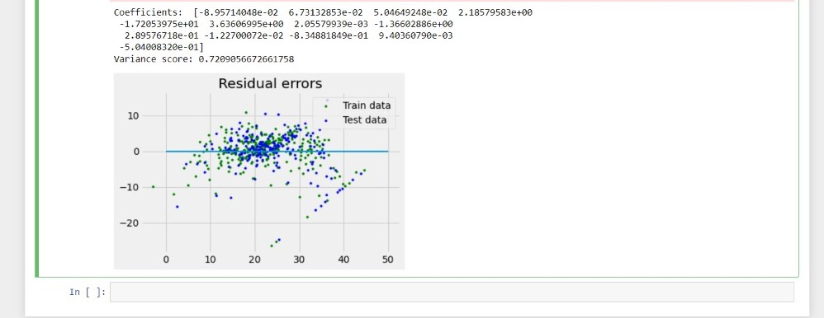

**Learning outcomes (What I have learnt):**

* 1. We learned about data analysis and data handling in python.
  2. We learned about various basic functions and libraries required for data analysis using python.
  3. We learned graphically analyze data functions of matplotlib library in python.
  4. We learned about linear regression and its implementation.

**Evaluation Grid:**

|  |  |  |  |
| --- | --- | --- | --- |
| s.no | **Parameters** | **Marks Obtained** | **Maximum Marks** |
| **1.** |  |  |  |
| **2.** |  |  |  |
| **3.** |  |  |  |
|  |  |  |  |